## Lab experiment -2

## NAME: SHALINI R K ROLL NO:230701304

**Design a UI where users recall visual elements (e.g., icons or text chunks). Evaluate the effect of chunking on user memory.**

FRAME 1:  
INSTRUCTION PAGE:

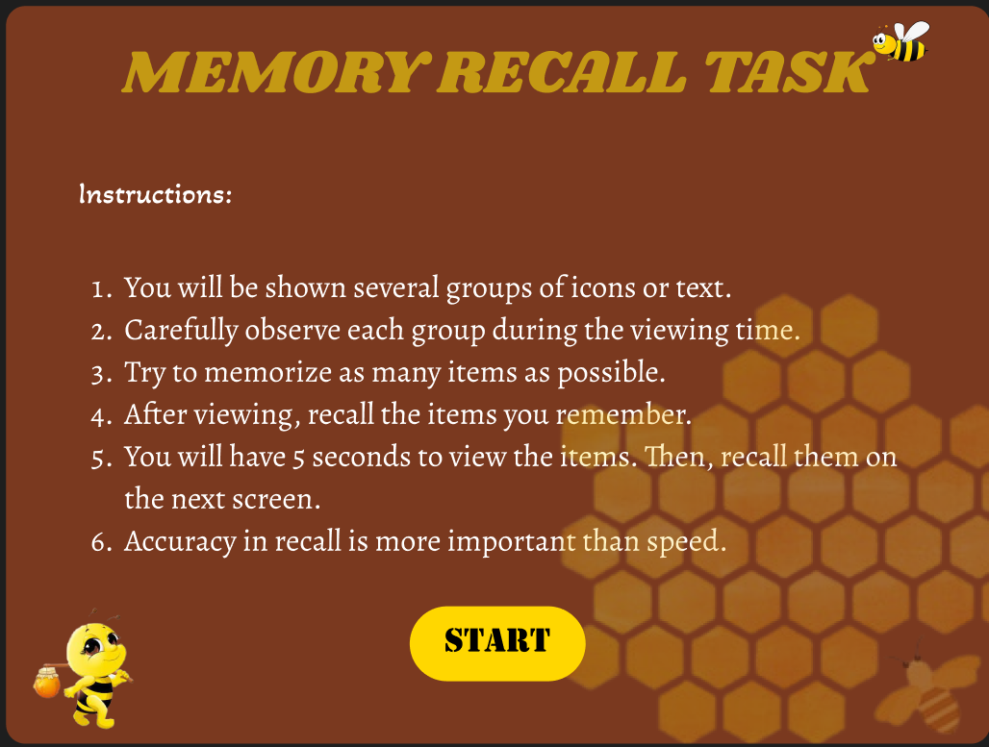

FRAME 2:

CHUNKING PHASE:

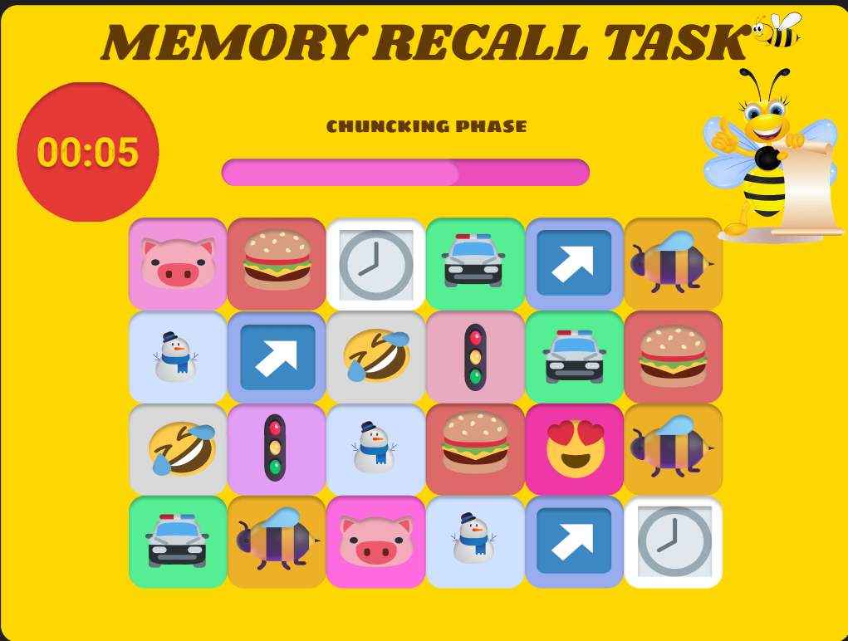

FRAME 3:

RECALL PHASE:

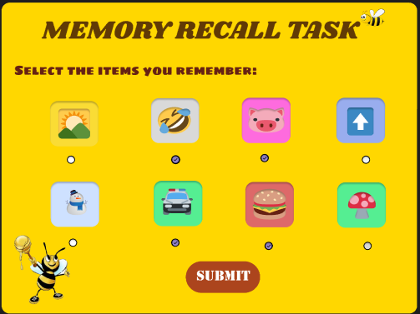

FRAME 4:

RESULT PAGE:

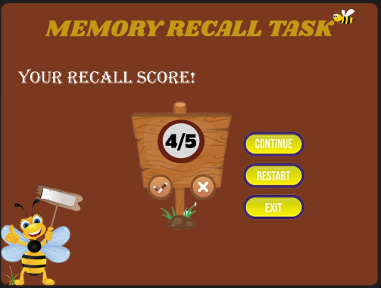

PROTOTYPE LINK:

<https://www.figma.com/proto/6zpZCiEwaGL4noMI7Y3w1R/chunking?page-id=0%3A1&node-id=2-2&p=f&viewport=-252%2C293%2C0.39&t=5TdEQelKQZq9mxCS-1&scaling=scale-down&content-scaling=fixed&starting-point-node-id=2%3A2>